10.80: a)
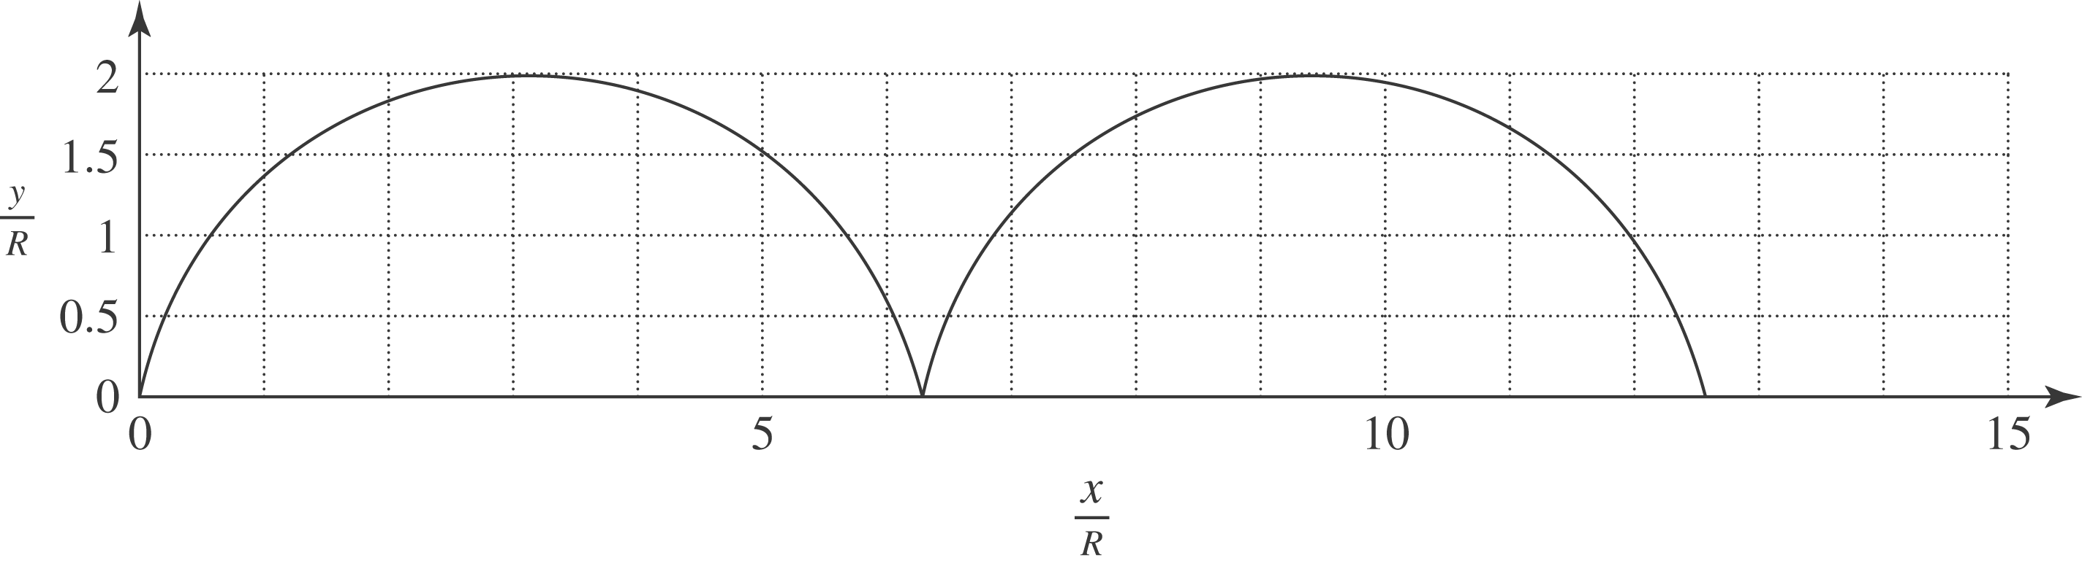
b) R is the radius of the wheel (y varies from 0 to 2R) and T is the period of the wheel’s rotation.
c) Differentiating,

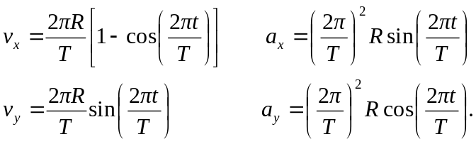

d) 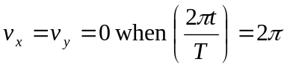or any multiple of 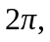 so the times are integer multiples of the period T. The acceleration components at these times are 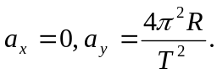
- 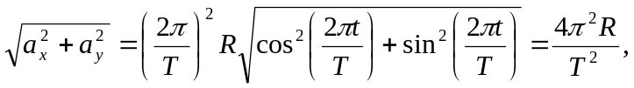

independent of time. This is the magnitude of the radial acceleration for a point moving on a circle of radius R with constant angular velocity 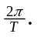 For motion that consists of this circular motion superimposed on motion with constant velocity 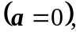 the acceleration due to the circular motion will be the total acceleration.

